RAMS READERS (Non-Fiction)

Name____________________________ Teacher_____________

Title of Book:____________________________ Grade: K

Main Idea (Who or what is this about?) Vocabulary (Two words that go with the topic.)

_______________________________ ______________________________

Facts (Draw one FACT from the book.) Facts (Draw another FACT from the book.)

_______________________________ ______________________________

1. Read the story.
2. Draw a picture in each box.
3. 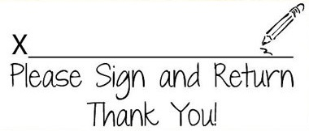Label the picture with 1 or 2 words.
4. Turn the paper into your teacher.